Fajitas
Ingredients
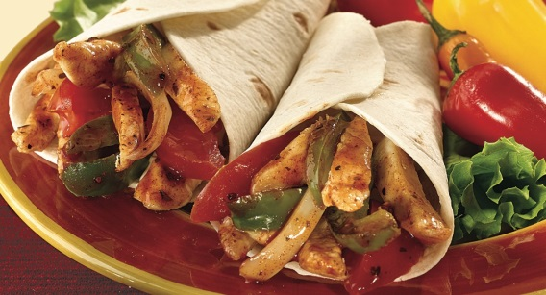
- ½ lime
- 1 clove garlic
- ½ green chilli
- Small bunch coriander
- 1 x 10ml spoon oil
- 1 small chicken breast (or 3-4 thighs)
- ½ onion
- ½ green pepper
- 1 tomato
- 25g cheddar cheese
- 2 tortillas
- 1 x 15ml spoon guacamole or salsa (optional)

Equipment
Chopping board
Sharp knife
Measuring spoons
Juicer
Mixing bowl
2 wooden spoons
Grater
Frying pan or wok

Method
- Prepare the marinade:
-Squeeze the lime
-Peel and crush the garlic (or slice it finely)
-Chop the coriander
-Stir everything together with the oil
- Remove any skin from the chicken and cut the meat into strips. Mix with the marinade and place in the fridge, covered, until needed.
- Prepare the remaining ingredients with a clean knife on a clean chopping board:
-Slice the onion and green pepper
-Chop the tomato
-Grate the cheese
- Add the marinated chicken to the wok or frying pan and stir-fry for about 4 minutes. Check that the chicken is cooked.
- Add the onion and green pepper and continue to cook for a further 2 minutes.
- Warm the tortillas in a microwave oven for 20 seconds, then lay flat on a plate.
- Spread a little chicken in the centre of the tortilla, add some tomato, cheese and guacamole, then roll up.

